“Outstanding GFWC Maryland Clubwoman Award”

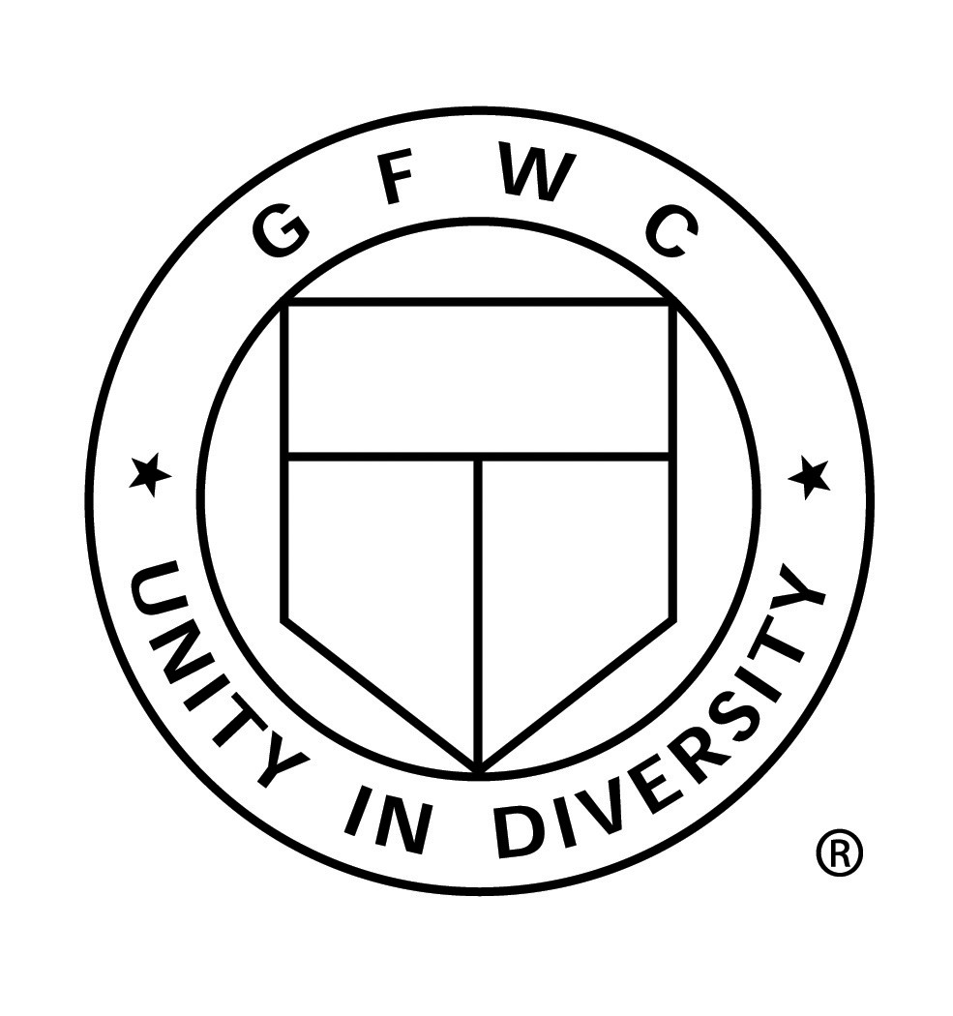
This award’s purpose is to honor one member
each year who exemplifies an outstanding
GFWC Maryland clubwoman.
This award was originally sponsored by Edith Klein,
Honorary State President 1978-1980 and the first award was presented to Barbara Pillote, May 1979.

Please think about your members and honor one of them by sending a letter of endorsement to our state president telling why your club values your member’s dedication, time and talents. Every club has more than one person who might fit the critieria of this award. Please take the time to honor one of your members this year and send your entry by March 1, 2024.

Please have your club choose a nominee now, and follow the guidelines to complete the coversheet and narrative entry form.

All entries must be postmarked to
Cynthia Dykes, GFWC Maryland President
by March 1, 2024

COVER SHEET
“Outstanding GFWC Maryland Clubwoman Award”

Name of Nominee: ____________________________________________________

Address of Nominee: ___________________________________________________

____________________________________________________________________

Telephone Number: __________________________________________________

Club Name: _________________________________________________________

Club President’s Name: ________________________________________________

_______________________________ _________________
Signature of Club President Date

NOTE: This cover sheet must accompany a separate sheet of narrative of 500 words or less entry (typed, double spaced). The supporting page of narrative must NOT contain the nominee’s name, club name, or dates to ensure anonymity in judging.

If you have any questions regarding this narrative, please contact the State Chairman:
Karen-Marie Wasik
sweetiekw104@gmail
240-620-9227

All entries must be postmarked by March 1, 2024 and mailed to:

Cynthia Dykes
GFWC Maryland State President
1407 W Sandy Acres Drive
Salisbury, MD 21804

“Outstanding GFWC Maryland Clubwoman” Award
RULES

- Nominees must be members in good standing of a general club of the GFWC Maryland Federation of Women’s Clubs, Inc.

- Ineligible members are: the current members of the GFWC Maryland Executive Committee, honorary GFWC Maryland State Presidents, former recipients of the award, and junior club members as the GFWC Maryland Juniors present their own Outstanding Junior Clubwoman Award each year.

- Only one nominee per club may be submitted. We recommend polling of all members to help choose your honoree.

- The COVER SHEET must be fully filled out and signed to be eligible.

- A separate page of narrative must be included containing 500 words or less, (typed, double spaced) explaining why the club believes the member is deserving of this award. Judging will be based on the nominee’s work in GFWC Maryland with the main emphasis placed on club sponsored activities accomplished in the year preceding the nomination. Additional background including club involvement over the years, along with any district and state activities may be included that indicate a strong, continuing interest in the Federation. In order for nominees to be anonymous during judging, the name of the nominee and the name of her club, and dates of service must be omitted from the main body of the narrative.

- The State President will number each entry and send copies of the numbered and anonymous narrative pages to the chairman of the OMC committee who will distribute copies of the numbered pages to her committee and ask for their top choice. The chairman will advise the State President of the number of award recipient and be given the names so she can make arrangements to honor each of the club nominees during the annual state convention and present of the award to this year’s Outstanding GFWC Maryland Clubwoman.

- To be eligible, all entries must be postmarked by March 1, 2024.
Please mail to:
Cynthia Dykes, GFWC MD President
1407 W Sandy Acres Drive, Salisbury, MD 21804.

